# Export declarations and CERTEX

AES sends two types of information to CERTEX: Ozone Depleting Substances and Fluorinated greenhouses gases (FGAS). Both of these are linked to a number of types of supporting documents and additional information in the export declaration. The rules which of these types are required for which products, are determined by TARIC, the European rules that are the core of TARBEL.

The overview below shows how these codes work for FGAS. For the codes in the red part, CERTEX only verifies that they are linked to a valid certificate.

The code in blue is contains the identification which CERTEX uses to identify to which account/certificate the information is linked.

The codes in yellow contain the quantities of CO2 and FGAS that CERTEX needs to know, and the exceptions to those codes. CERTEX not only checks the validity of this information, but also tracks the declared quantities relative to the quantities in the license.

The code in black is also covered by the rules in TARBEL, but is not verified by CERTEX

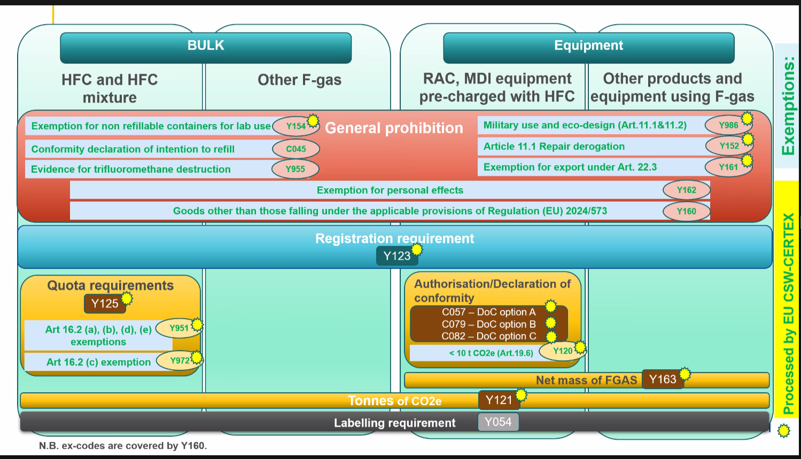

A similar overview exists for ODS, but I have not been able to get it. It looks very similar.

# How to fill in the declaration to avoid a rejection by CERTEX

**FGAS**

|  |  |  |  |  |
| --- | --- | --- | --- | --- |
| **Registration formalities** | **Y123** | Undertaking registered according to Art.20 of Regulation (EU) No 573/2024.  “Registration ID” obtained from FGAS Portal. | FGAS Portal Registration ID | <AdditionalReference>  <type>Y123</type>  <referenceNumber>123457</referenceNumber>  </AdditionalReference> |
| **General prohibitions** | **Y154** | Exemption from import/export prohibition on containers, non-refillable or without refilling provisions, for fluorinated greenhouse gases, empty or fully or partially filled, for laboratory or analytical uses according to Article 11.3 of Regulation (EU) 2024/573; | an..70 | <AdditionalReference>                  <type>Y154</type>                  <referenceNumber>2423685</referenceNumber>  </AdditionalReference> |
| **Y161** | Exemption from export prohibition according to Article 22.3, second subparagraph of Regulation (EU) 2024/573 | an..70 | <AdditionalReference>                  <type>Y161</type>                  <referenceNumber>84827</referenceNumber>  </AdditionalReference> |
| **Information requirements** | **Y121** | Tonnes of CO₂ equivalent of bulk gases and of gases contained in products or equipment, and parts thereof | n..16.6 | <AdditionalReference>  <type>Y121</type>  <referenceNumber>3375</referenceNumber>  </AdditionalReference> |
| **Y163** | Net mass of fluorinated greenhouse gases charged in products and equipment | n..16.6 | <AdditionalReference>  <type>Y163</type>  <referenceNumber>5000</referenceNumber>  </AdditionalReference> |

**ODS**

|  |  |  |  |  |
| --- | --- | --- | --- | --- |
| **Registration formalities** | E013 | Export licence for ozone-depleting substances and equipment in accordance with Article 16 of Regulation (EU) 2024/590; | EXP-xxxxxxxx-xxxxxxxx- xxxxxxxx | <SupportingDocument>                 <type>E013</type>                 <referenceNumber>EXP-HA84P-EHCO-2000-00061038</referenceNumber>                            </SupportingDocument> |
| **Information requirements** | Y797 | ODS Licensing System registration identification number as defined in Article 17.3 (a) of Regulation (EU) 2024/590 | an..35 | <AdditionalReference>                  <type>Y797</type>                 <referenceNumber>ODSHA84P</referenceNumber>  </AdditionalReference> |
| Y798 | Declaration of net mass of ozone-depleting substance(s), when included in products and equipment | n..16.6 | <AdditionalReference>                     <type>Y798</type>                 <referenceNumber>10</referenceNumber>  </AdditionalReference> |
| Y799 | Net mass of the ODS multiplied by the ODP of the ozone-depleting substance(s), also when included in products and equipment. | n..16.6 | <AdditionalReference>                     <type>Y799</type>                 <referenceNumber>8800</referenceNumber> </AdditionalReference> |

**Notes:**

* **IMPORTANT: do not put any other information in reference fields, or Certex will reject the declaration. No EORI’s, no unit qualifier, nothing.**
* The ODS License number is EXP-xxxxxxxx-xxxxxxxx-xxxxxxxx where the first three characters refer to the license type(EXP=Export), the second group of characters can have a length from 4 to 8 characters, the third four characters refer to the type of the Export license, afterwards the year of the issuing of license is indicated as well as a generic system number’.
* n..16.6 = 16 digits before the decimal point **(use a point, no comma!)** and up to 6 digits after. Also, **no units like KG, TON, etc.** These are implied in the name of the supporting document or additional reference